Question 4

Follow the following command to compile and run the program:

To compile g++ -pthread 4.cpp -o 4

where 4.cpp is our program file name.

To run: ./4 90 81 78 95 79 72 85

NOTE: You might have to press enter one more time to signify that input has been taken, like shown in the figure below.

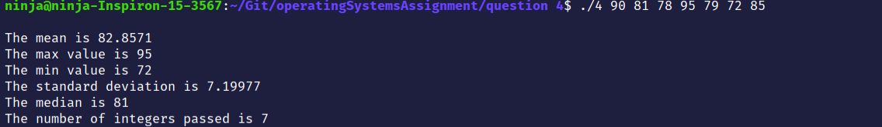

We have written this program using threads on linux, so this would run in a linux environment.